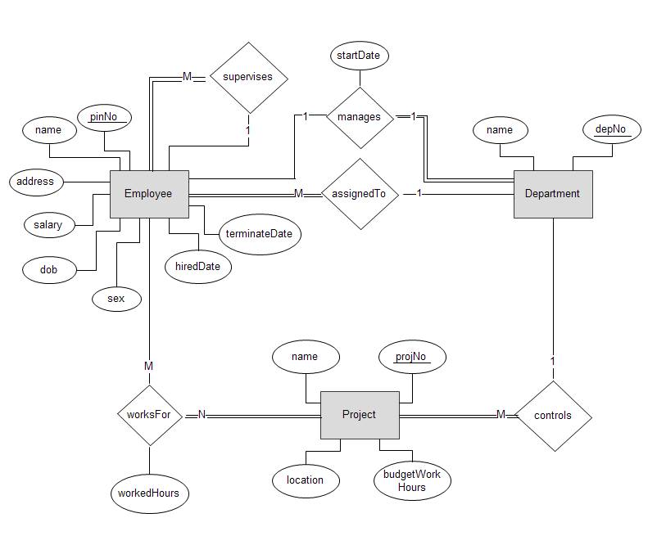

EMPLOYEE

Dep. No.

Terminate- date

Hired-date

Sex

Pin No.

Name

Address

Salary

Dob

DEPARTMENT

Start date

Manage pin no.

Dep. No.

Name

PROJECT

Name

Dep. No

Budget work hours

Location

Project no

WORKS-FOR

Worked hours

Project no.

Pin no